LAB 321Assignment | Type: | Long Assignment
LAB 321Assignment | Code: | J3.L.P0064
LAB 321Assignment | LOC: | 400
LAB 321Assignment | Slot(s): | 10

Title: Register Restaurant (Nếu chọn bài này thì không được chọn bài 66)

Background
Restaurant provide services that customer can order a party online. The restaurant also has promotion programs

Program Specifications

Program a web site display the detailed information of a restaurant

Features:

This website contains following main functions
- Function 1: Register account
- Function 2: Login
- Function 3: Register a restaurant
- Function 4: Display Restaurant Details
  - View detailed information
  - Add comments
  - Rate restaurant
  - List all comments
- Function 5: Add Images

Database description
- Database must contain promotion detail information displayed on the screen

Expectation of User interface:

PIC 1: Register a Account

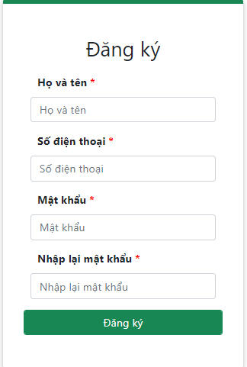
Note: The following fields must be displayed
- When the user registered successfully, the system redirect to Login page

PIC 2: Login

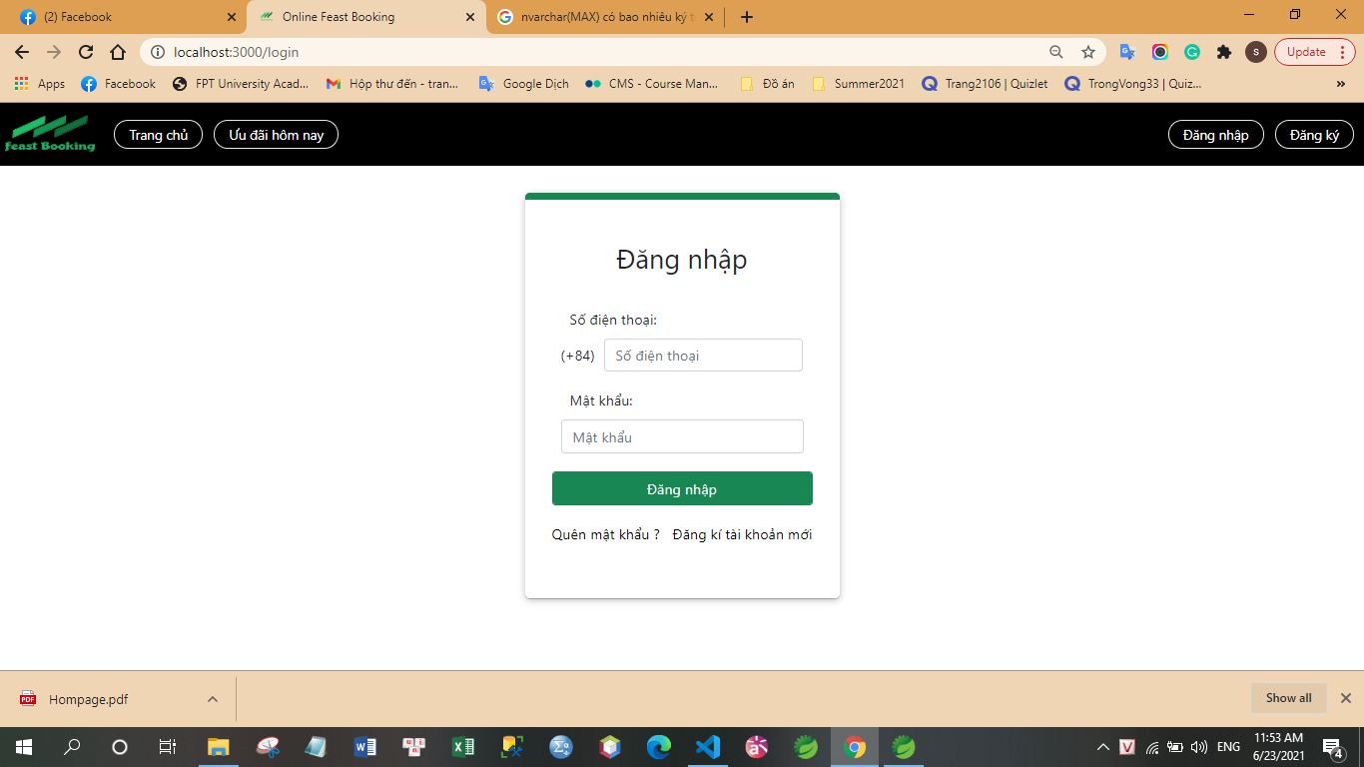

Note: The following fields must be displayed
- Mobile No
- Password
- Login button

PIC 03: Register a Restautant

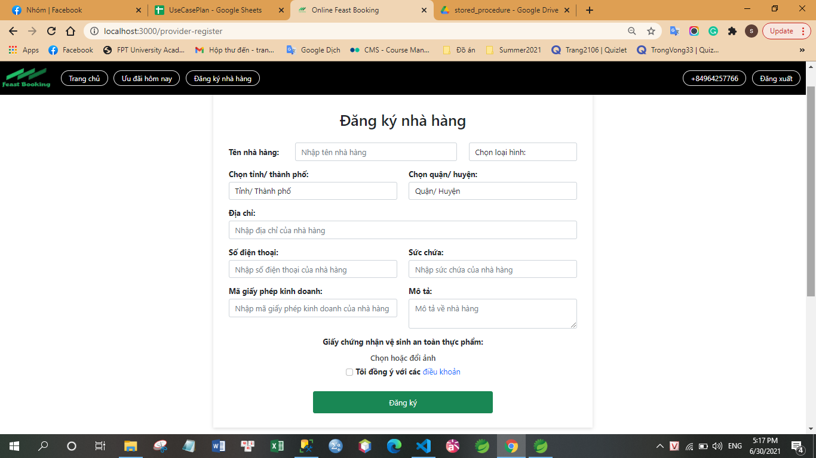

Note:
- When the user click on “Register”, the system will validate data
  - If the data is valid, the system insert data into database, and then redirect to Login page
  - If data is invalid, the system will show detailed message about error
- When user click on “Select or Change” button, the screen “Add Image” is display, this screen allow user can add many images (maximum is 16 images). After images are added, it is shown on the screen

PIC 04: Restaurant Details

Note: The following fields must be displayed
- All fields in the screen must be got from database
- When user click on “Back”, the previous picture will be displayed
- When user click on “Next”, the next picture will be displayed

PIC 05: Add Image Details

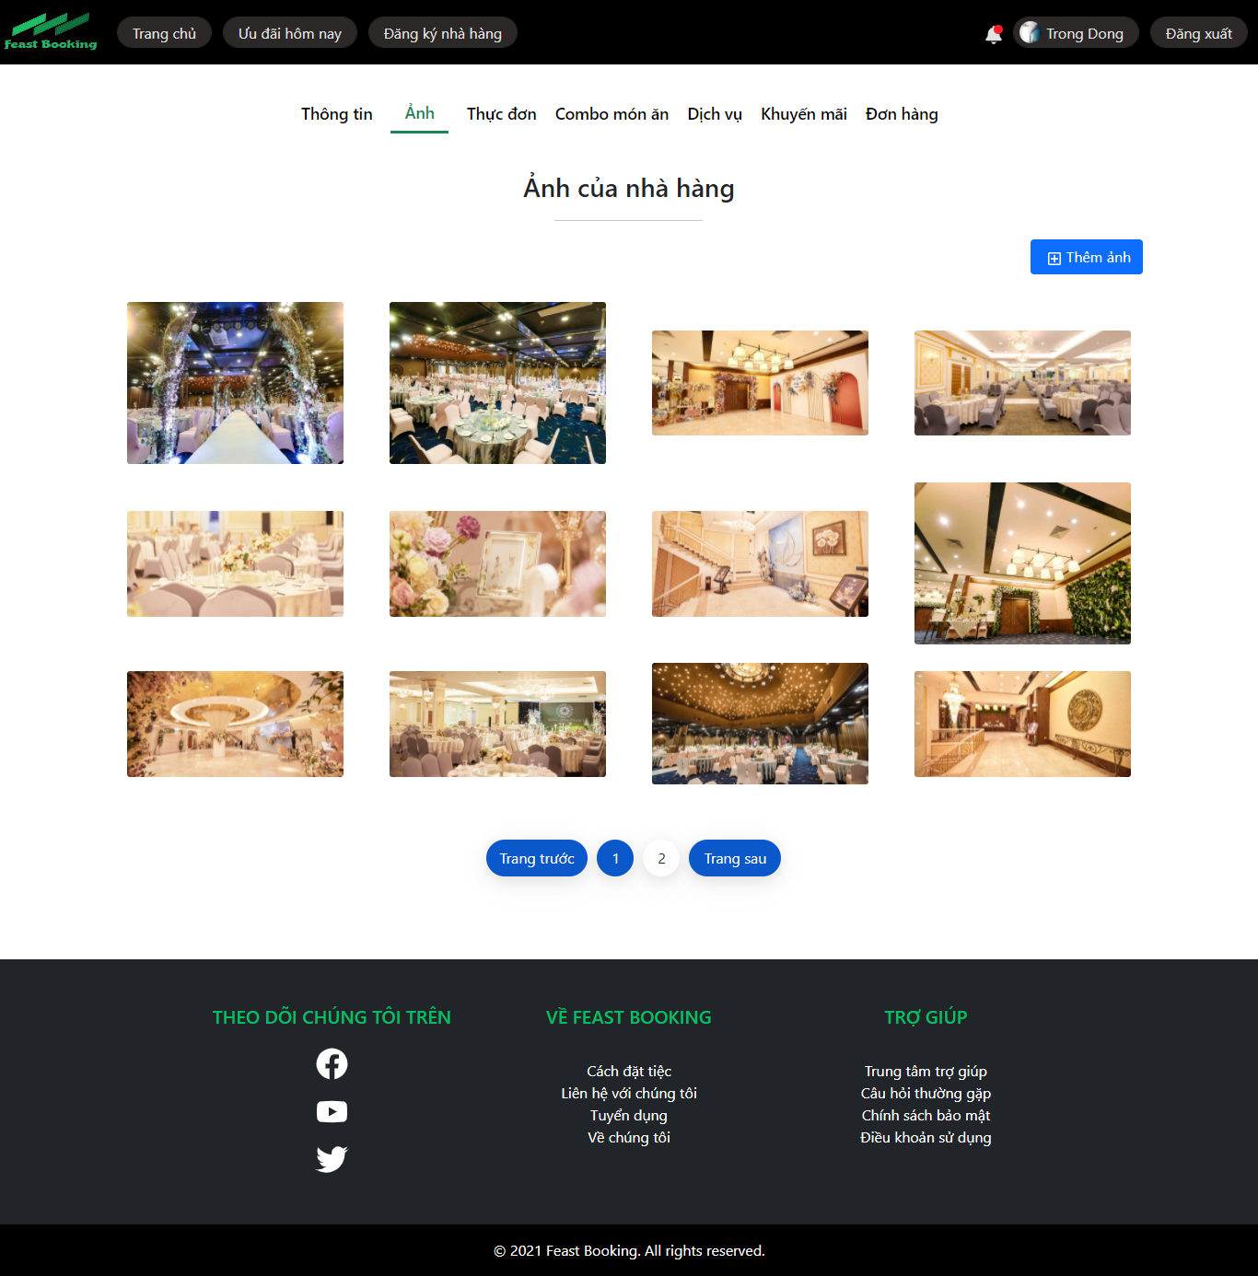



Guidelines
- Step 1 : Create web layout
- Step 2 : Create prototype
- Step 3 : Design database base on created prototype
- Step 4 : Code & Test

